**1.Applying Styling on Header and Footer**





**2. Adding a Custom Page Property in AEM**

Open CRXDE Lite and Locate the Page Component and define a New Page Property l(ike custom page property) in cq:dialog.

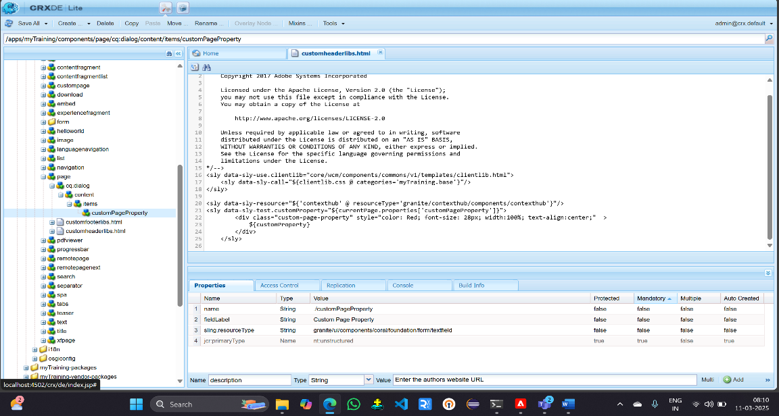

save and Test the Custom Page Property.

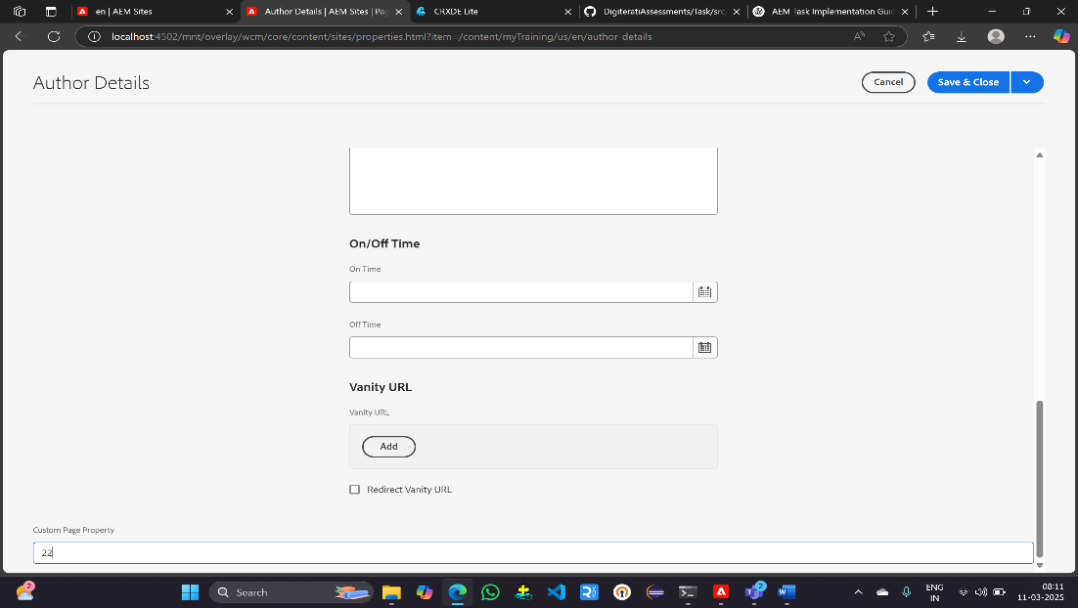

In custom property field I had given a value and that value is displayed in the author component

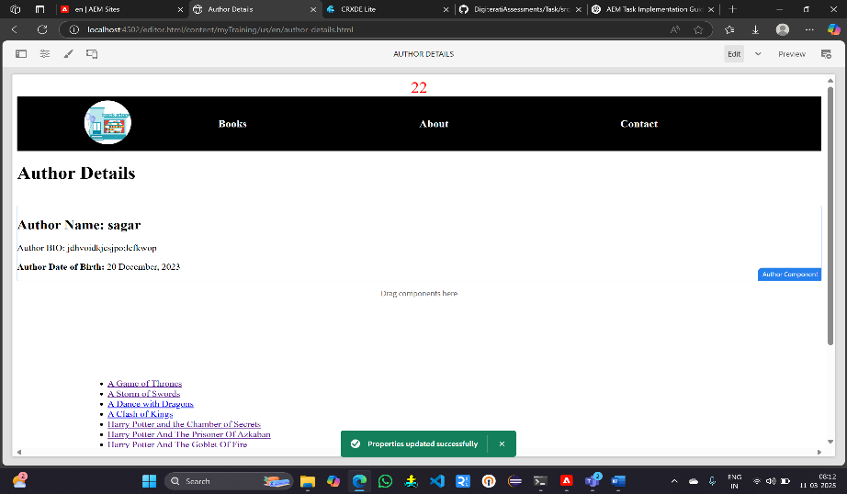

**3 Adding One Property to the Author Component**

Open CRXDE Lite and Locate the Author Component and add a New Property (like authorWebsite) in the cq:dialog. It creates a new text field for Author Website in the dialog.

Stores the value under authorWebsite.

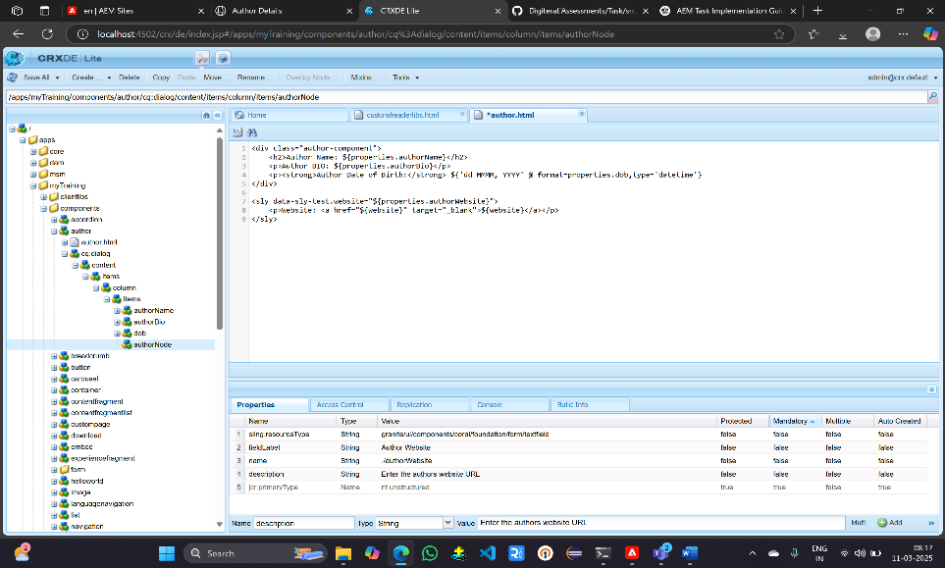

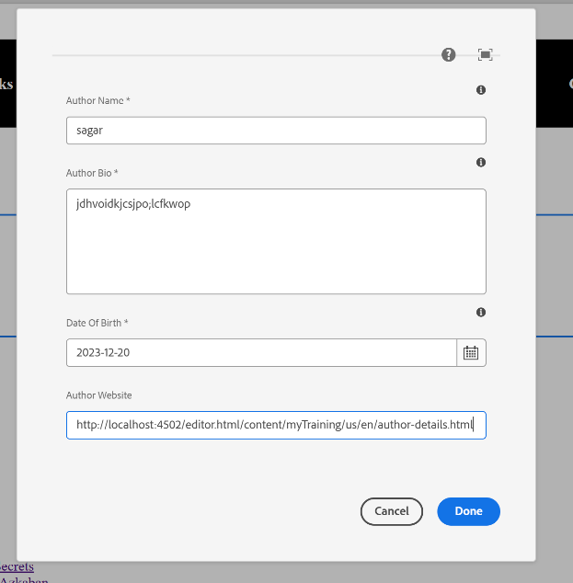 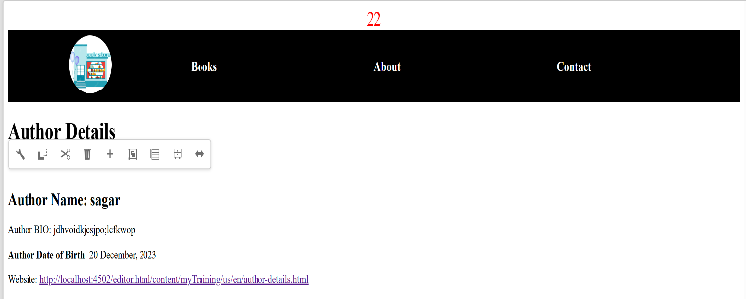

**4.** **Adding a Multi-Field Text Field in the Author Component and Writing a Model**

Open /apps/<your-project>/components/author/cq:dialog add the following multi-field structure inside the items node

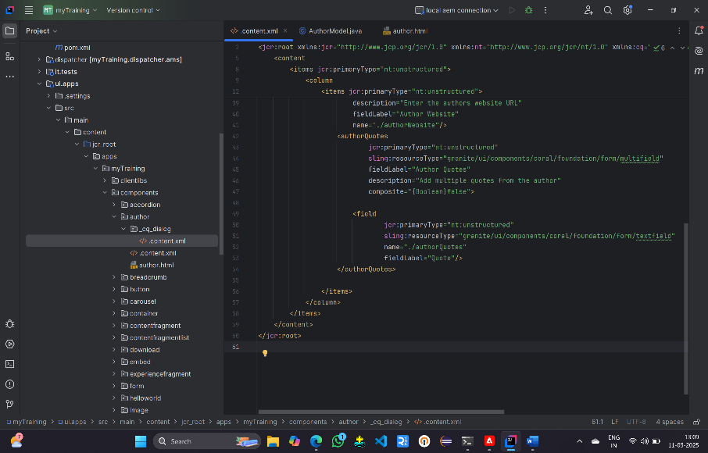

Create a Sling Model to Fetch Multi-Field Data

1. Navigate to your **core bundle** (/apps/myTraining/core/src/main/java/com.myTraining.core/models).
2. Create a new Java class AuthorModel.java

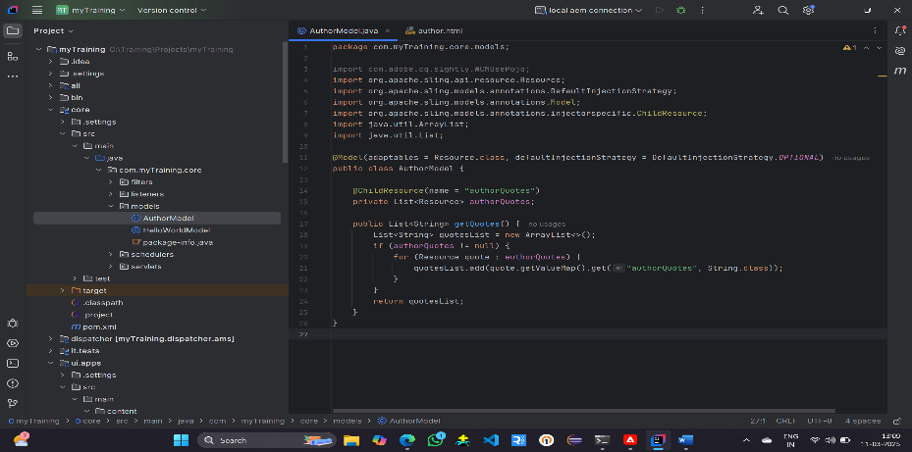

Fetch and Display Multi-Field Data in HTL

1. Open /apps/ myTraining / components/author/author.html.
2. Add the following code:

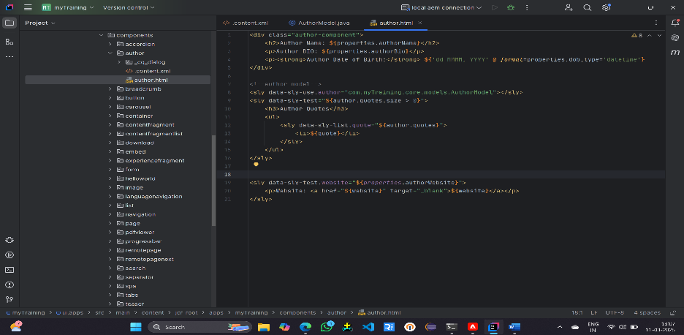

Verify in AEM

1. Go to AEM Page Editor.
2. Drag and drop the Author Component onto a page.
3. Open the dialog, add multiple quotes, and save.
4. Refresh the page.
5. The quotes should be displayed in a list format.

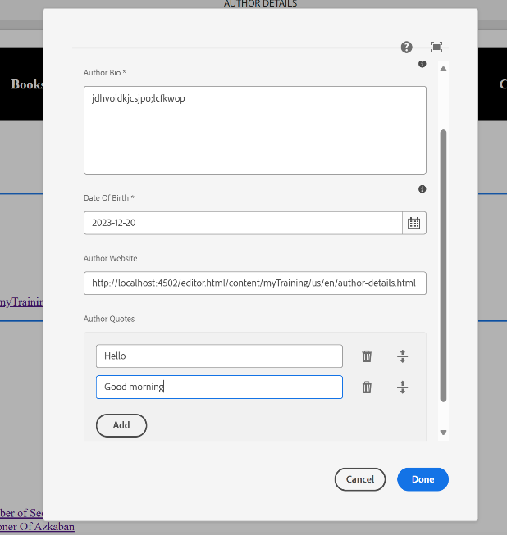 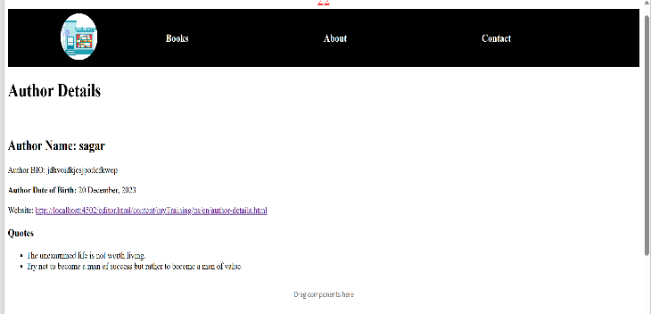

**5.Adding "Add Script" Property to the Book Page Component**

Add the "Add Script" Field in page component dialogs.

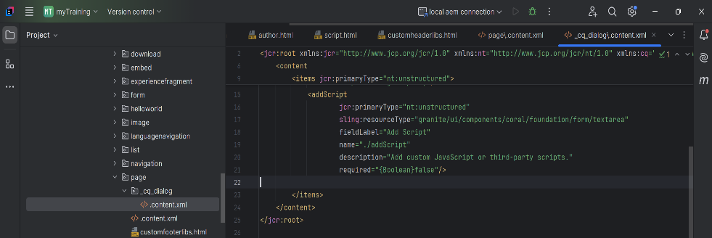

After saving the changes:

1. Open Page Properties of any book page.
2. Add some JavaScript (e.g., <script>alert('Hello AEM');</script>).
3. Save & Publish the page.
4. Check if the script is saved in CRXDE Lite under:

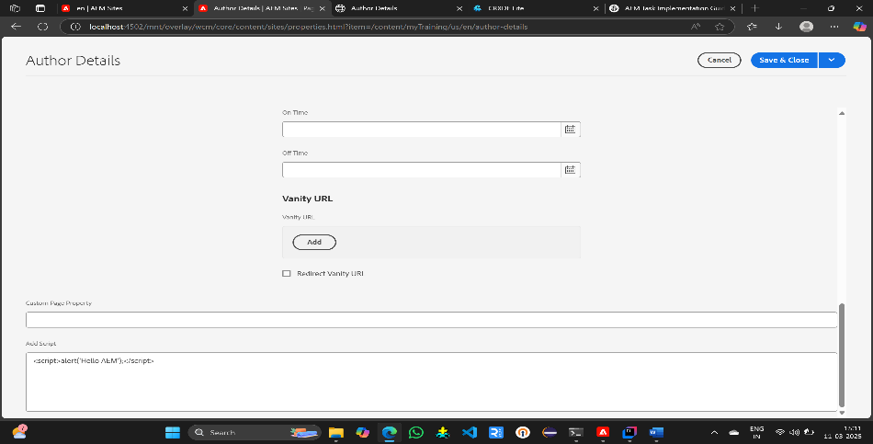

Fetch the "Add Script" Property in script.html

* 1. Create script.html in /apps/myTraining/components/page
  2. Add the Following Code

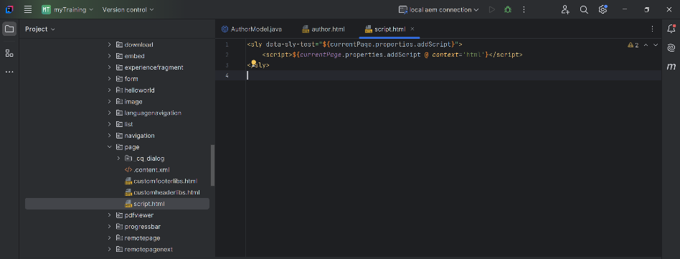

Include script.html in customheaderlibs.html

